Enquiry Curriculum Map – Peregrines -Term 6 2024

**Maths**

This term we will continue our work on decimals.

We then move on to converting units and measurement and volume.

Finally, we will move on to consolidating our learning in year 5 in preparation for moving in to year 6.

**Saving our planet**

Class book focus: Holes

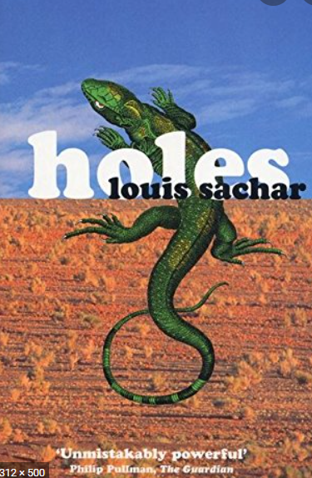

**Design and Technology**

We are going to design and build a bird house. This will involve; accurate measuring, sawing, joining using wood glue and hammer and nails and drilling.

We will then place our bird boxes around school.

**Computing**

Impact of ICT and network and online security

**PSHE**

Changing me

Look at self and body images, changes in girls’ bodies, changes in boys’ bodies, conception and looking ahead to being a teenager.

**SPANISH**

The Planets – naming them and describe them using temperature, distance from the sun and position.

**ENGLISH**

Our writing unit will focus on Holes. We will be writing setting descriptions and non-chronological reports. We will be using our skills to skim and scan large chunks of texts to retrieve information about a given subject. We will use our skills of inference to understand how a character is feeling.

We will then move onto non-fiction writing focusing on our Geography topic, Saving our planet. We will write persuasive letters and non-chronological reports.

As always, the children will be expected to write neatly with accurate punctuation and in paragraphs. They should show a range of sentence types and a broad range of vocabulary choices.

**MUSIC**

We will be forming the choir for Year 6’s production. Our music will focus around learning the songs.

**Geography**

**Saving our planet**

We will begin focusing on our planet’s sustainability. We will examine different areas of our world including oceans, rainforests and the polar regions. We will explore the effects pollution and human habitation are having on these areas. We will look at renewable energy sources and alternative materials that promote sustainability.



**R&B**

What do religions say to us when life gets hard?

(Islam, Hinduism and Humanism)

Exciting events:

Children need to be available for the 5/6production on Tuesday 16th July at 5.45pm.

On 1st July we will be attending SBL for a STEM day.

**PE**

In our Tuesday lessons with the sports coaches, we will be participating in tennis activities.

For the first half of the term, on Wednesday’s we will be focusing on athletics in preparation for sports day on Wednesday 19th June 2024. Later in the term, we will be learning different styles of rounders.

**SCIENCE**

Living things and their habitats. We will continue looking at life cycles and reproduction in mammals, birds, reptiles, and insects.