Enquiry Curriculum Map
This map shows areas of study for Year 5 and gives you a flavour of the questions we will be investigating. Within each area the learning and expected outcomes will be scaffolded appropriately for your child.
Geographer
We will explore Locational knowledge - locate the World’s countries, using maps to focus on Europe, and North and South America, concentrating on their environmental regions, key physical and human characteristics.
Identify countries, and major cities - identify the position and significance of latitude, longitude, Equator, Northern Hemisphere,
Southern Hemisphere, and the Tropics.
Engineer/Artist

We will be creating our own artist representations of the solar system using a variety of different mediums.
Exploring different textures and using a variety of resources.
Our artwork will take place throughout our first enquiry question and work displayed around our classroom.

Mathematician

Our focus will be number and place value.
Revisiting reading, writing, ordering and comparing numbers up to one million.
Using mathematical skills to explore negative numbers and rounding.
Also, we will use our addition and subtraction skills with larger numbers and looking at mental calculations methods.

Timetable Rockstars:
Spend 15 minutes 3 times a week on TTRS – we will set you on the correct table after assessing in school.

Enquiry Question:

What does the solar system look like from earth?

Term: 1

Year Group: 5

Computers
We will be focusing on:
Systems and searching: by recognising IT systems around us and safe accessing.

Author
As authors we will be using the book “How to live forever” by Colin Thompson. We will write setting descriptions using expanded noun phrases. We will write balanced arguments using modal verbs.
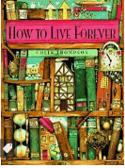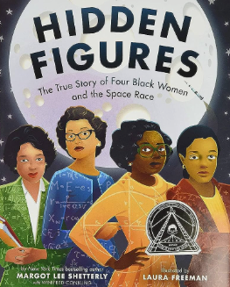
Our second unit, will be based on the book “Hidden figures”. This unit will link our written work to our enquiry. We will write diary entries and newspaper articles recalling key events and use our editing skills to improve our work.
Our final unit, is non-fiction. We will produce a double page spread capturing the new knowledge we have acquired through our enquiry learning.
Musician
The theme is Earth and the focus is listening and composing.

Philosopher : RE
We will explore what it means to be a Muslim in Britain today.

Philosopher : PSHE
We will construct our class charter and explore the topic of Being in my world with Jigsaw Jack.

Athlete
Our PE focus will be Kabaddi/dodgeball and tag rugby taught by (Bristol Sport), these are to take place on Tuesday and Wednesdays.

Linguist
Continuing to learn Spanish including using the correct masculine and feminine terms.
Exploring food and drink preferences.

Scientist
Earth and space
We will:
- describe the movement of the Earth and other planets relative to the Sun in the Solar System -
describe the movement of the Moon relative to the Earth - describe the Sun, Earth and Moon as approximately spherical bodies
across the sky.

We will be working scientifically - using test results to make predictions to set up further comparative and fair tests – reporting and presenting findings from enquiries, including conclusions, causal relationships and explanations of results, in oral and written forms.

