What grows near me?
Key vocabulary plants |  | Key Vocabulary food
Wild plants  A wild plant seed grows where it falls.  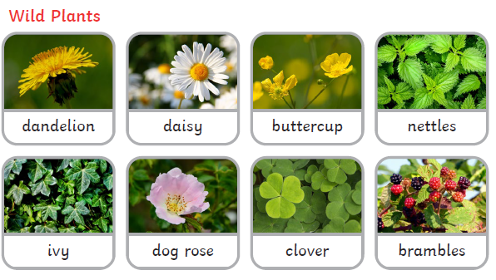 |  | Fruit  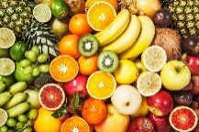 | comes from the flowering part of a plant and contain seeds
 |  | Vegetable  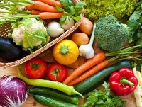 | The edible part of plants such as leaves, stem, roots and bulbs.
Garden plants  Garden plants are plants that people choose to grow in their gardens or allotments. They can be fruits, vegetables or flowers.  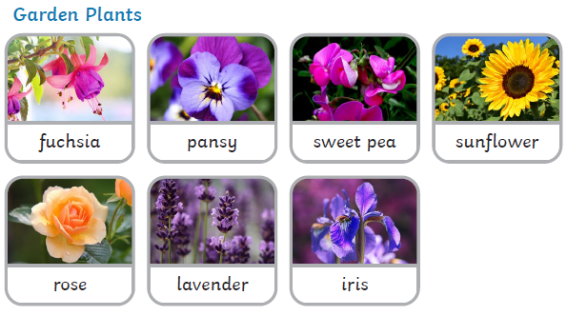 |  | grown | fruits and vegetables are grown from seeds and bulbs that have been planted in soil
 |  | farmed | meat is reared on farms
 |  | caught | fish is caught from seas and rivers
 |  | method | the steps you need to follow to make food from a recipe
weeds | weeds are wild plants that that grow in places NOT chosen by people | cut  chop | separate into smaller pieces
Deciduous trees loose their leaves every year.  The leaves on deciduous trees change colour and fall off every Autumn.  They usually have no leaves on their branches in Autumn.  Here are some examples:  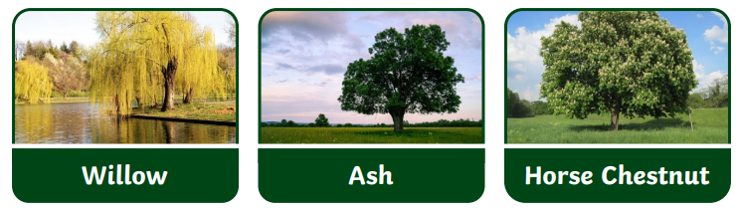 |  | 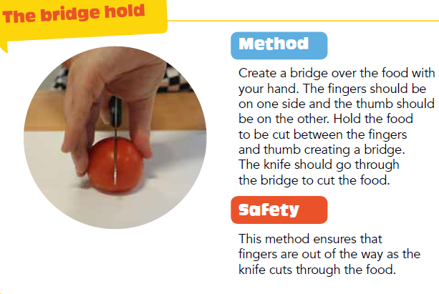
Evergreen trees have green leaves all year round. Their leaves do not fall off or change colour in the autumn. Evergreen trees instead loose leaves gradually and not all at once.  Here are some examples:  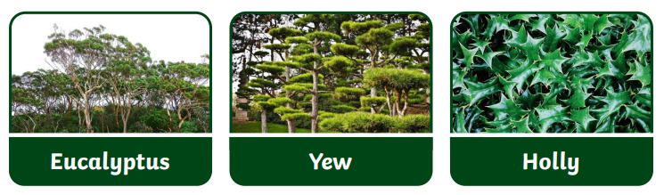 |  | 