Enquiry Curriculum Map YEAR 1 TERM 3
Mathematician

Know that numbers can be shared into 2 parts and explore the number bonds for all numbers up to 10.

Know the different ways to make numbers to 10. For example quickly know that 9 can be made of: 9 and 0 8 and 1 7 and 2 6 and 3 5 and 4 etc.

Accurately count out a set of up to 20 objects.

Count forwards to 70 and backwards from at least 20.

Write numbers to 20 and be able to place them on an empty number line.

Count in steps of 2, 5 and 10 – forwards and backwards within 20, 50 and 100.

Name 3D shapes including cubes, cuboids, spheres, pyramids and cones. Know the properties of each shape including number and shape of faces and number of vertices.

Read and tell half past times on the clock.

This map shows areas of study for Year 1 and gives you a flavour of the questions we will be investigating. Within each area the learning and expected outcomes will be scaffolded appropriately for your child.
Historian

Look at the past, present and future and explore changes. How have the important people in our lives changed from being a baby to the present time? How have hospitals changed? Learn about Princess Campbell and the influence that she has had in the nursing world. Touch on the idea that some people (in the past) were treated differently and unfairly.

Artist
We will sketch winter trees from observation taking inspiration from Beatrix Potter’s sketches. We will use lines of different thicknesses to create the thinner and thicker branches.

We will look at the work of Sarah Applebaum and experiment with making simple designs and dyes using fabrics.

Computer Engineer

Moving a robot

Writing short algorithms and programs for floor robots, and predicting program outcomes.

PE
Gymnastics
Multi sports – throwing/catching

Enquiry Questions:

How does Wick change in winter?



Who helps who?
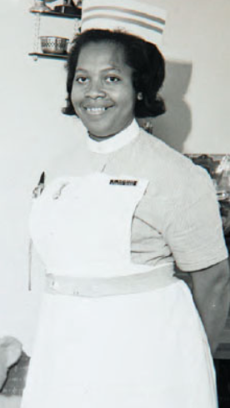

Writer / Author
Traditional Tales – Little Red Riding Hood

Write neat letters that are correctly formed. Show letters of the correct size with most sitting neatly on the line and tall letters clearly shown and letters that go below the line clearly shown.

Write simple sentences and phrases that can easily be read by others.

Independently spell words that contain the phonemes taught in Year R and in Terms 1 and 2 of Y1.

Write sentences with clear finger spaces between each word.

Add a capital letter at the beginning of each sentence and a full stop at the end.

Plan and write a story based on the ideas from Little Red Riding Hood. For example, change the character of the wolf to another one who then poses a problem in the story.

Musician
In music, children will be learning a new song called The King is in the Castle – they will be learning about song structure, rhyme patterns, sound quality (timbre), dynamics and pitch. They will create sound sketches linked to the song, and practise changing their voices to suit different characters in the song.
Philosopher: RE
Who is Jewish and what do they believe?
Ask some questions about believing in God and offer some ideas of their own. Have a virtual tour of a synagogue and / or listen to a Jewish visitor speaking about their faith.
Philosopher: PSHE
Dreams and Goals
Talk about challenges and facing up to them. Discuss not giving up and trying until they have achieved their goal. The children are encouraged to think about jobs that they might like to have when they are older and are taught to associate what they learn now with being able to have that job.

Scientist

Observe how winter weather changes and how day length varies. Name the months of year and seasons in order.
Make pictures tables and charts to show changes in the weather and temperature and how plants are dormant and how animals find food and shelter.

Ideas to support your child at home:
Please see the homework overview for this term with optional tasks. This can be found in homework folders.
This term, we hope to create a display showcasing people who help us, comparing Princess Campbell and her role to that of another nurse from our school community. We would warmly welcome any parent or guardian who is a nurse and would like to come to talk to the class about their job, show any photos and items they use and explain how their role is helpful to others. We can be flexible with timings for visits from Week 3 onwards. Please call in to see me if you can help. Thank you. The children will be encouraged to ask questions of the visitors and record what they’ve learnt with pictures and writing.

