Enquiry Curriculum Map YEAR 1 TERM 6
This map shows areas of study for Year 1 and gives you a flavour of the questions we will be investigating. Within each area the learning and expected outcomes will be scaffolded appropriately for your child.
Mathematician
Number bonds: Know all the ways to make 10 and 20. Know the pairs of numbers by heart: 15 + 5, 16 + 4, 17 + 3 etc.

Count forwards and backwards to 100 and read the numbers.

Count in steps of 2, 5 and 10 – forwards and backwards.

Name 3D shape and know their properties.

Know that the values of a digit changes according to where it is in the number – Place value.

Tell the time to the hour and half past.

Completing addition and subtraction expressions and equations within 20.

Historian

What did adults in class and at home play when they were at school?
Why is playing games with friends important?
How have toys changed? What are the changes between games played many years ago and games played now?
Can you make a game box with instruction of how to play the game you have made?

Computer Engineer
Programming animations
Designing and programming the movement of a character on screen to tell stories
PE
Swimming
Athletics

Enquiry Questions:
How could we play in different ways?
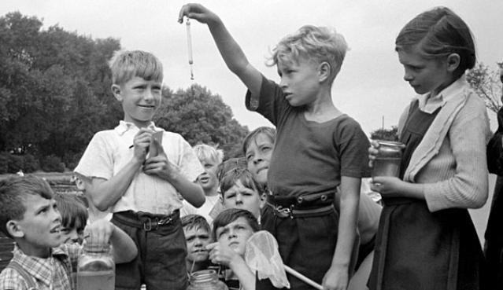

How does Wick change in summer?

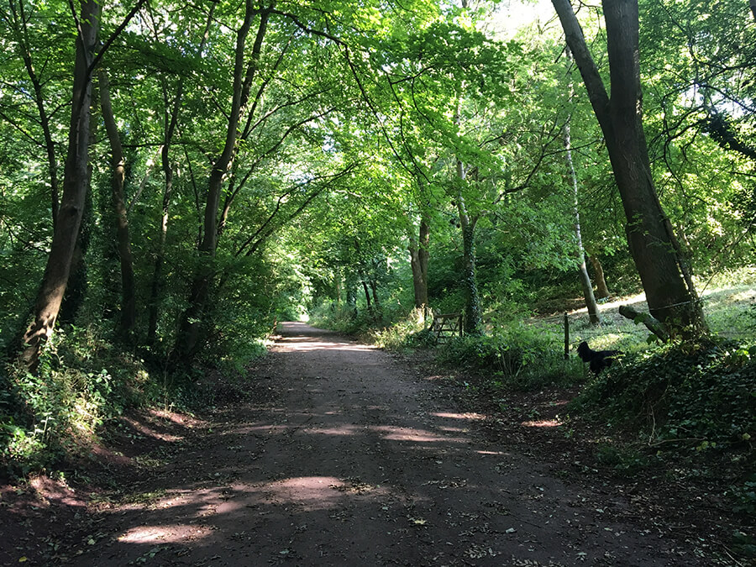

Writer / Author
Focus on writing sentences with correct and consistent punctuation: Capital letters, full stops, question marks, exclamation marks, capital letters for the names of people and places.

Write in the correct present or past tense.

Spell words ending in: ing, ed, est, er.
Spell words with the prefix: un

Spell Year 1 keywords correctly within sentences.

With support, identify spelling errors and make necessary corrections.

Using the book ‘Toys In Space by Mini Grey:
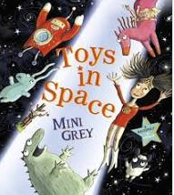

- Retell the exact story
- Write detailed descriptions of the setting and the characters and the night sky.
- Write fact files about toys old and new.

Musician
Rehearse songs for the summer song festival.

Philosopher: RE
Who made the world?
(Christianity and Judaism)

Philosopher: PSHE
Changing Me

I am starting to understand the lifecycles of humans and animals.
I can tell you some things about me that have changes and some things that have stayed the same.
I can identify the parts of the body that make boys different to girls and can use the correct names for penis and vagina.

Artist

Paul Klee inspired block printing

Street Art inspired stencil printing
Ideas to support your child at home:
Please keep up with reading 4 times each week.
Talk about the lifecycles of any pets or animals that are relevant to your child’s interests. Observe nature in your locality and talk about how it changes in Summer. Share ideas about how the children have grown and changed.
Talk about the games and toys that different generations of your family enjoyed as children.
Spend some time observing the night sky and encourage the use of interesting adjectives to describe the scene.

